**CAN I GET PREGNANT WITH PCOS?**

Everything for a girl is already planned in families. How will she study, at what age she will marry and sometimes these expectations go on to how many children she will conceive! There’s a hidden happiness hiding behind these thoughts in a parent’s heart. Hearing that I can’t get pregnant with PCOS diagnosed is something not expected to a newly-married girl.

PCOS or simply Polycystic Ovary Syndrome is a number of symptoms combined in a package that makes pregnancy. Ovaries are the reproductive organs of female bodies present each side of the lower abdomen. And these ovaries are responsible for the process of ovulation i.e. release of eggs that further lead to pregnancy. Now, ‘Polycystic’ means ‘many cysts’ that are formed in either ovary leading to dangerous symptoms including problems with pregnancy.

**What is Polycystic Ovary Syndrome (PCOS)?**

Polycystic Ovary Syndrome affects a woman’s hormone levels. There are two main hormones called estrogen and progesterone secreted by follicles (present in ovaries), responsible for female characteristics. And a hormone called androgen, responsible for some male features present in females (like hairy skin, heavy vocals etc).

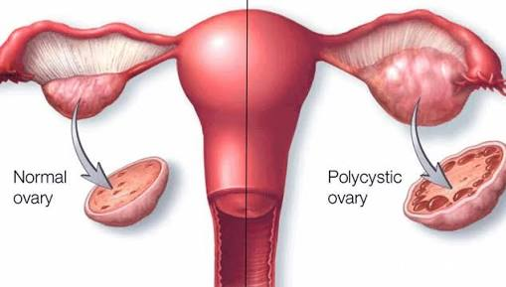

What Polycystic Ovary Syndrome does is, it increases the amount of androgen secretion greater than usual amounts. This causes malfunctioning of the female body and trying to conceive with PCOS becomes difficult.

**Why is PCOS caused?**

No particular root of this Polycystic Ovary Syndrome is yet found, but doctors believe that there are some cases particularly pointing towards a main reason. It is found that gene flow, insulin resistance and inflammation are major causes of production of excess androgen.

* Gene flow

Genes carry the characteristics features of the basic structure of a human being. And since ages, some diseases are carried forward in further off-springs (by genes). Polycystic Ovary Syndrome is one among such genetic diseases that is gifted to off-springs by their previous generations.

* Insulin resistance

Insulin is a hormone secreted by pancreas to balance sugar levels in the body. If the insulin isn’t secreted in proper amount (it may be more or less than usual amount), body loses control and acts irrelevantly.

Disturbed insulin levels are believed to cause PCOS in ovaries.

* Inflammation

Women with PCOS often have higher levels of inflammation caused by overweight (in mostly cases). Lowering weight can help lowering PCOS intensity to some extent.

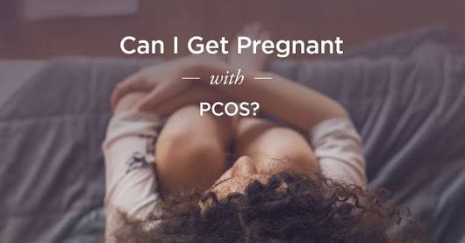

**GET PREGNANT WITH PCOS**

Get pregnant with PCOS is something unexpected yet astonishing! Isn’t it? A step-wise guide is appreciated rather than thinking harder about what to do and end up doing nothing!

**What are various symptoms associated with PCOS?**

Generally, women aged between 15-44 years (from menarche to menopause stage) experience Polycystic Ovary Syndrome. PCOS might have been genetically inculcated or may have made home in women body after gaining sudden weight. Here are the symptoms associated with PCOS:

* Irregular periods

Irregular periods may be a visible sign of having PCOS found our body! Regular gynaecology check-ups are advised in cases of irregular, heavy or late menstruation. Irregular periods may lead to building up of uterus lining and eventually a heavy period can be witnessed.

A woman diagnosed with PCOS can experience 7-8 periods in a year or maybe less.

* Hair growth

An unusual hair growth on genital areas and face is the most visible change that can be noticed. We must keep a close notice of our body functioning to cure the diseases on time before it gets too late!

* Acne and skin darkening

Acne and skin darkening are common factors that most women have to get through in teenage years. But there is a limit to everything that happens! An extreme change must be noticed and taken care of.

* Sudden weight gain

Another important aspect that needs to be addressed as soon as it is found is weight gain. Nowadays, people are very conscious about their weights especially women. A special care is demanded here too.

* Headaches and baldness

A sudden hair fall leading to baldness (patterns like on man’s scalp) may appear followed by headaches as a symptom.

The above-mentioned symptoms must be checked wisely without acting lazy to avoid PCOS taking a dangerous form. Birth control pills and diabetes drugs are said to reduce (or fix, in some cases) hormonal imbalance a well.

**Trying to conceive with PCOS**

Polycystic Ovary Syndrome causes complications in pregnancy by interrupting in menstrual cycle. If someone is trying to conceive with PCOS already, few things must be taken care of. For example, level of PCOS must be consulted and pregnancy should be continued only if feasible. Various helpful options are available like fertility treatments which improves ovulation process and increases chances of safe conceiving.

If someone wants to get pregnant with PCOS, there is a high risk of hormone imbalance and improper functioning of organs. Keeping in mind the side effects, PCOS and pregnancy tests are done to increase possibilities to get pregnant with PCOS.

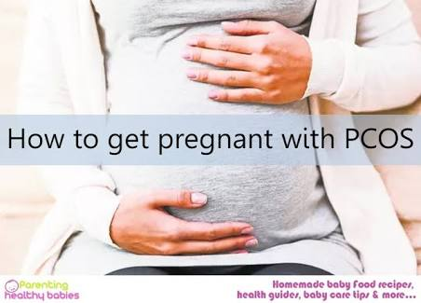

**Natural ways to get pregnant with PCOS**

**“Weight loss” tops the list!**

Loosing weight can reduce risks up to 80%. Hard to believe, but it’s the truth. Go for a diet that helps reducing weight and contains essential nutrients required by the body. A healthy body welcomes happiness and moves away sadness and here sadness comes into play with higher cholesterol levels, high insulin secretion, higher risks of heart diseases and diabetes.

What to do to get pregnant with PCOS? We have to choose a balanced diet and keep this sadness at a distance! Low-carb diets are beneficial. Natural ways to get pregnant with PCOS include loosing weight as eating a healthy diet is most suited!

**Exercising connects heart to health**

If not vigorous running and sweating, light exercises (like yoga) are also proved beneficial in cases of major diseases and protected patients from deadly diseases too! Meditation and exercise fills a person with positive thoughts and energy that is most required in life.

The question is: can I get pregnant with PCOS? And the simplest answer is yes! With every ‘yes’ follows some minor terms and conditions that needs to be remembered.

These were two genuinely easy-to-follow natural ways to get pregnant with PCOS.

**PCOS and pregnancy tests**

Once a pregnancy test gives positive results, women trying to conceive with PCOS can actually get pregnant with PCOS. PCOS and pregnancy tests can work together!

Pregnancy tests look for a hormone called HCG in blood or urine samples and if it gives a false negative test, it might be due to irregular periods. Consult a specialist for better results rather than doubting what to do and what not to.

**Getting pregnant with PCOS at old age**

What really happens as a woman with PCOS ages? Levels of androgen (male hormone) decreases with age and the imbalance comes to a ‘normal’ level eventually, allowing a women to get pregnant with PCOS! Sex hormones and regular periods make way granting a woman’s need to get pregnant with PCOS. Getting pregnant with PCOS at old age is thus comparatively easier than young ‘child-bearing aged’ women. It might sound satisfactory but getting pregnancy with PCOS at old age is something no woman would like to do.

The final decision is up to us! We have to decide best things for ourselves and what we desire.